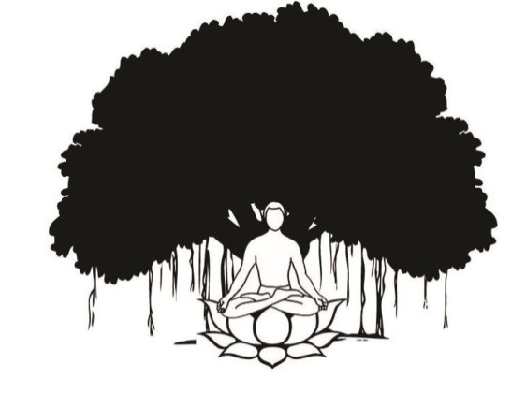 | Yogada  In the Himalayas  An Ashram style Yoga & wellness Retreat on the banks of the Ganges  Shivpuri – 249192 RISHIKESH India
Yoga Course - Registration Form YTTC 200 Hours

Name of the Person
Sex :
Date of Birth :
Address

Passport Details | Passport No.  Place & date of Issue:
Telephone Nos  E Mails: | Residence: Mobile :
Telephone Nos  E Mails: | E mail:

Package to be booked: YTTC 200 hours
Duration : Number of Nights | From | To | Accommodation Option
20 Night & 21 Days
Other Services : ( If Any) Such as pick up & Drop transfers from Delhi or Dehradun Airport and accommodation in Rishikesh before the starting of the course.
Details:

Date :

Name :

Mode of Payment
Payment Details:
Registration Fee | USD 333 or Equivalent of the amount in INR has to be paid at the time of making the Registration
Final Payments | Balance amount has to be paid the time of Check in upon arrival at Yoagda.

Option A -
You can make the payment through the credit card/debit. Please click on the following link which will take you to
our secured Indian Bank account payment Gateway.
Being a Indian bank the payments are accepted only in Indian Rupees.
http://www.rishikesh.in/payment-lock.php

The above link is password protected and you need the following details

User Name : rishikesh
Password : Ganga@RKSH+2026
Also do not use any signs before & after the amount e.g / - , . .
Please confirm when you have paid.

As per todays conversion Rate 1 USD =

Option B.
Payment with transfer wise: you can use the website ot make the payments.
www.transferwise.com

Option C.
Bank Transfer- You can order your bank to transfer the advance in our account for which you need following bank details
Details required for sending Advance money to our account ( Your bank to Our Bank )
Beneficiary : High Bank Himalayan Retreat
Account No. 50200089708530
Bank: HDFC Bank
Address: HDFC Bank TAPOVAN – 249192 (Tehri Garhwal) Uttarakhnd, INDIA
Swift Code: HDFCINBBXXX

Yogada is venture of High Bank Himalayan Retreat
Cancelations:
If you do not come for the course the registration fee is nonrefundable. However you can still use your money as below.
Cancelations – Made One week & Before : 75% of the amount can be used for your stay in future courses or retreats *
Cancelations – within one week: 50% of the amount can be used for your stay in future courses.*
*Valid for another one year from the original date of course.

